**Trace hea[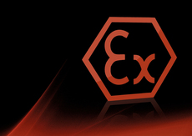](http://eltherm.com/mod/Products/Ex-Area+-UK.htm?id=610)ting**

**Asgard Industrial Systems Ltd are Irelands Sole distributors and stockists for eltherm trace heating products and systems.**

**We offer the complete range of eltherm self-regulating and non-self-regulating trace heating cables, as well as flexible heated hoses, heated jackets temperature controllers and accessories.**

**Trace Heating Cables**

Eltherm are a leading manufacturer of self-regulating, constant wattage and series (resistance) heating cables and manufacture all of these cables at their plant near Siegen in Germany. A full range of ATEX approved hazardous area variants is also available.

**Self-Regulating Cables, ELSR..xx**

Self-regulating cables are the most commonly used trace heating cables for frost protection and process temperature maintenance applications. That is, they are used to replace the heat lost through a pipe or vessels thermal insulation, thus ensuring that that the pipe or vessels temperature is maintained at the target level (ie for frost protection, this is typically 5 degrees C).

[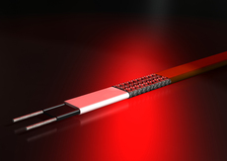](http://eltherm.com/mod/Products/Heating+cables+|+heating+tapes+/Self+regulating+heating+cables-UK.htm?id=606)ELSR-LS range:

* Outputs from 10W/m up to 30W/m
* Available in 230VAC and 110VAC
* Max temperature withstand energised = 65°C, de-energised = 80°C
* ATEX approved (230VAC variant)

ELSR-W range:

* 55°C and 65°C nominal temperatures for hot water maintenance
* 230VAC
* Max temperature withstand energised = 80°C, den-energised = 100°C
* Also suitable for higher temperature process temperature maintenance

ELSR-H range:

* Outputs from 10W/m up to 60W/m
* 230VAC and 110VAC variants available
* Highest temperature withstand:
  + Up to 120°C energised
  + Up to 200°C de-energised
* Corrosion resistant fluoropolymer outer sheath

**Resistance Heating Cables**

[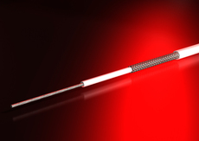](http://eltherm.com/mod/Products/Heating+cables+|+heating+tapes+-UK.htm?id=604)Eltherm manufacture constant power resistance based heating cables (the ELK range) with different outer sheaths/jackets in order to cater for the temperature of the application

ELKM – PTFE insulated cables for applications up to 260°C (25W/m)

ELK-H – Glass cloth insulated for applications up to 450°C (approx. 125W/m)

ELK-Q – Quartz insulated for applications up to 900°C (approx. 150W/m)

ELK-MI – Mineral insulated cables for applications up to 600°C /1000°C (approx. 250W/m)

[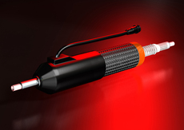](http://eltherm.com/mod/Products/Heated+hoses-UK.htm?id=608)**Heated Hoses**

eltherm are the world’s foremost manufacturer of flexible heated hoses, which are pre-traced internally in order to provide temperature maintenance of fluids and gases. Typically, construction includes one or more carrier hoses, which are then traced with either self-regulating or constant power heating cable, before being insulated and then finished as a ready to connect item. Hoses can also be manufactured to ATEX requirements and to handle the most corrosive of materials

[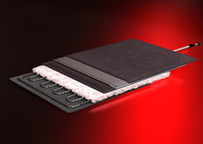](http://eltherm.com/mod/Products/Heating+mats+|+heating+jackets-UK.htm?id=609)**Heated Jackets**

Eltherm design and manufacture bespoke electrically heated jackets, providing a close-fitting, ready to connect temperature maintenance solution for vessels and objects up to 900°C. Jackets can also be designed and manufactured to ATEX requirements

**Controllers and Accessories**

Asgard Industrial Systems offer the full range of Eltherm electronic temperature controllers as well as general surface heating accessories.